String Operations: to know length of first name below mentioned code we need to write

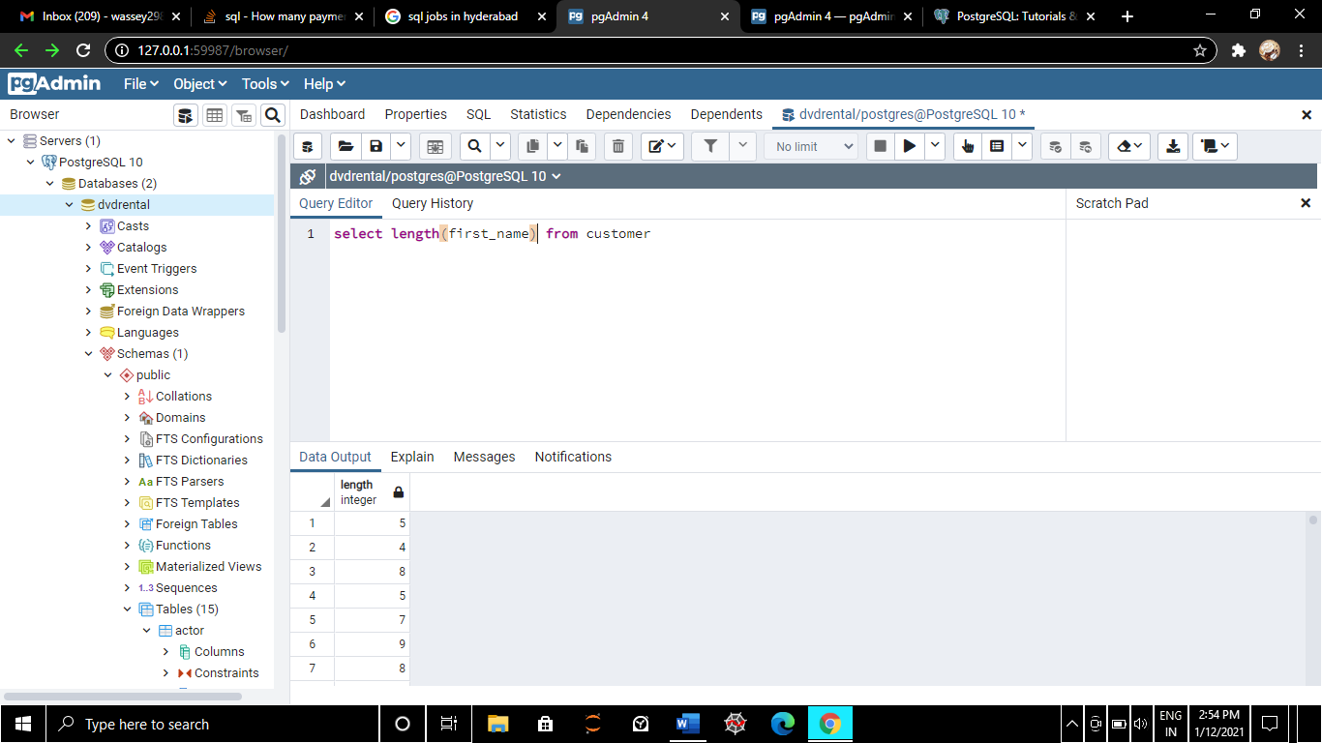

To concatenate first name along with last name

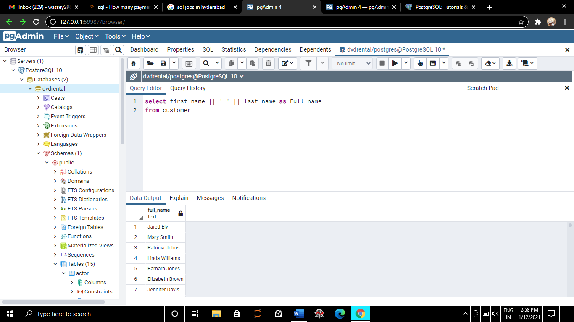

To concatenate first name along with last name making it Upper case

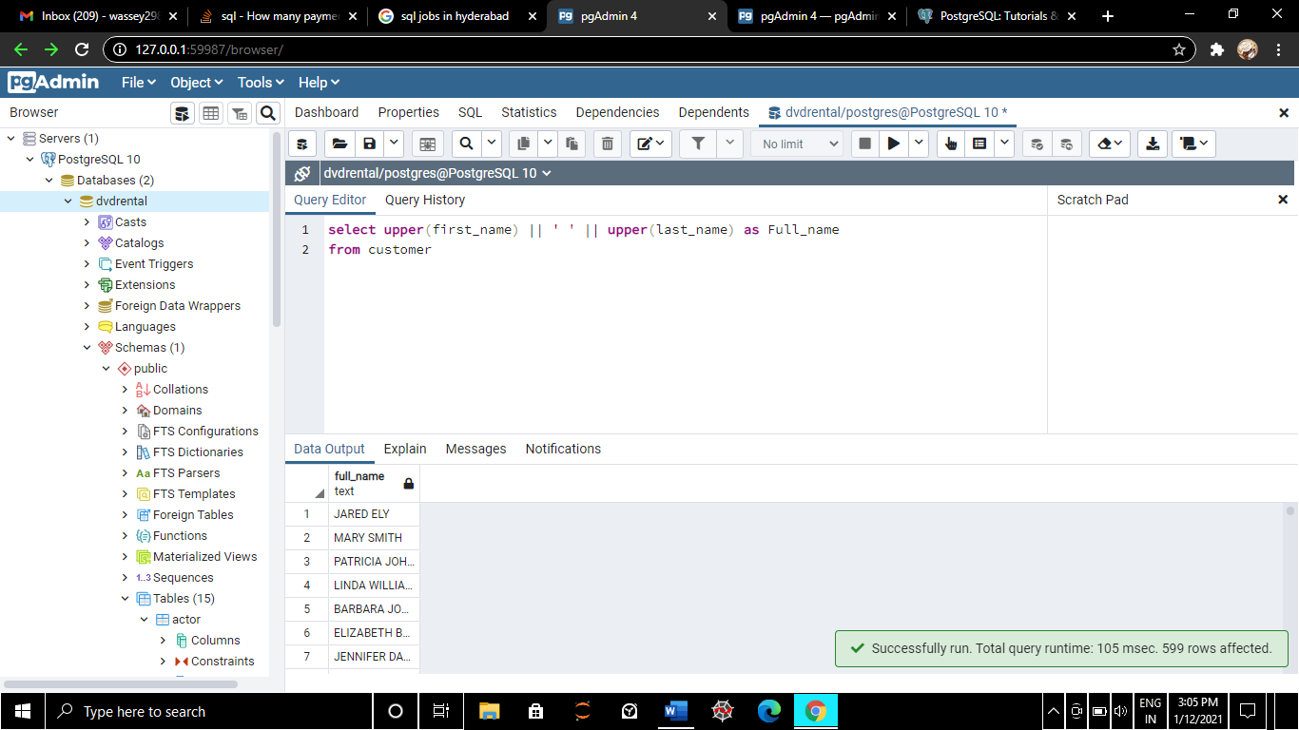

To concatenate first name along with last name making along with email and making a custom email

